Project Design Phase
Solution Architecture

Date: | 15 Feb 2026
Team ID: | LTVIP2026TMIDS35994
Project Name: | Househunt: finding your perfect rental home
Maximum Marks: | 4 Marks

1. Solution Overview
The Rent Ease – House Rental Management System is a web-based application designed to simplify the house rental process by providing a centralized digital platform for renters, property owners, and administrators. The system enables users to register, list rental properties, search available houses, place booking requests, and manage rentals efficiently using a secure and scalable MERN stack architecture.

2. Functional Description
The system consists of the following major modules:
• User Authentication Module – Handles user registration and login using JWT-based authentication.
• Property Management Module – Allows property owners to add, update, and delete rental property listings with images.
• Property Search Module – Enables renters to browse and search available rental houses.
• Booking Management Module – Handles booking requests, approvals, and booking status updates.
• Admin Management Module – Allows administrators to manage users, properties, and booking approvals.
• Database Module – Stores user, property, and booking data securely in MongoDB.

3. Architecture Diagram
The solution architecture follows a client–server model using the MERN stack:
- Frontend: React.js
- Backend: Node.js with Express.js
- Database: MongoDB
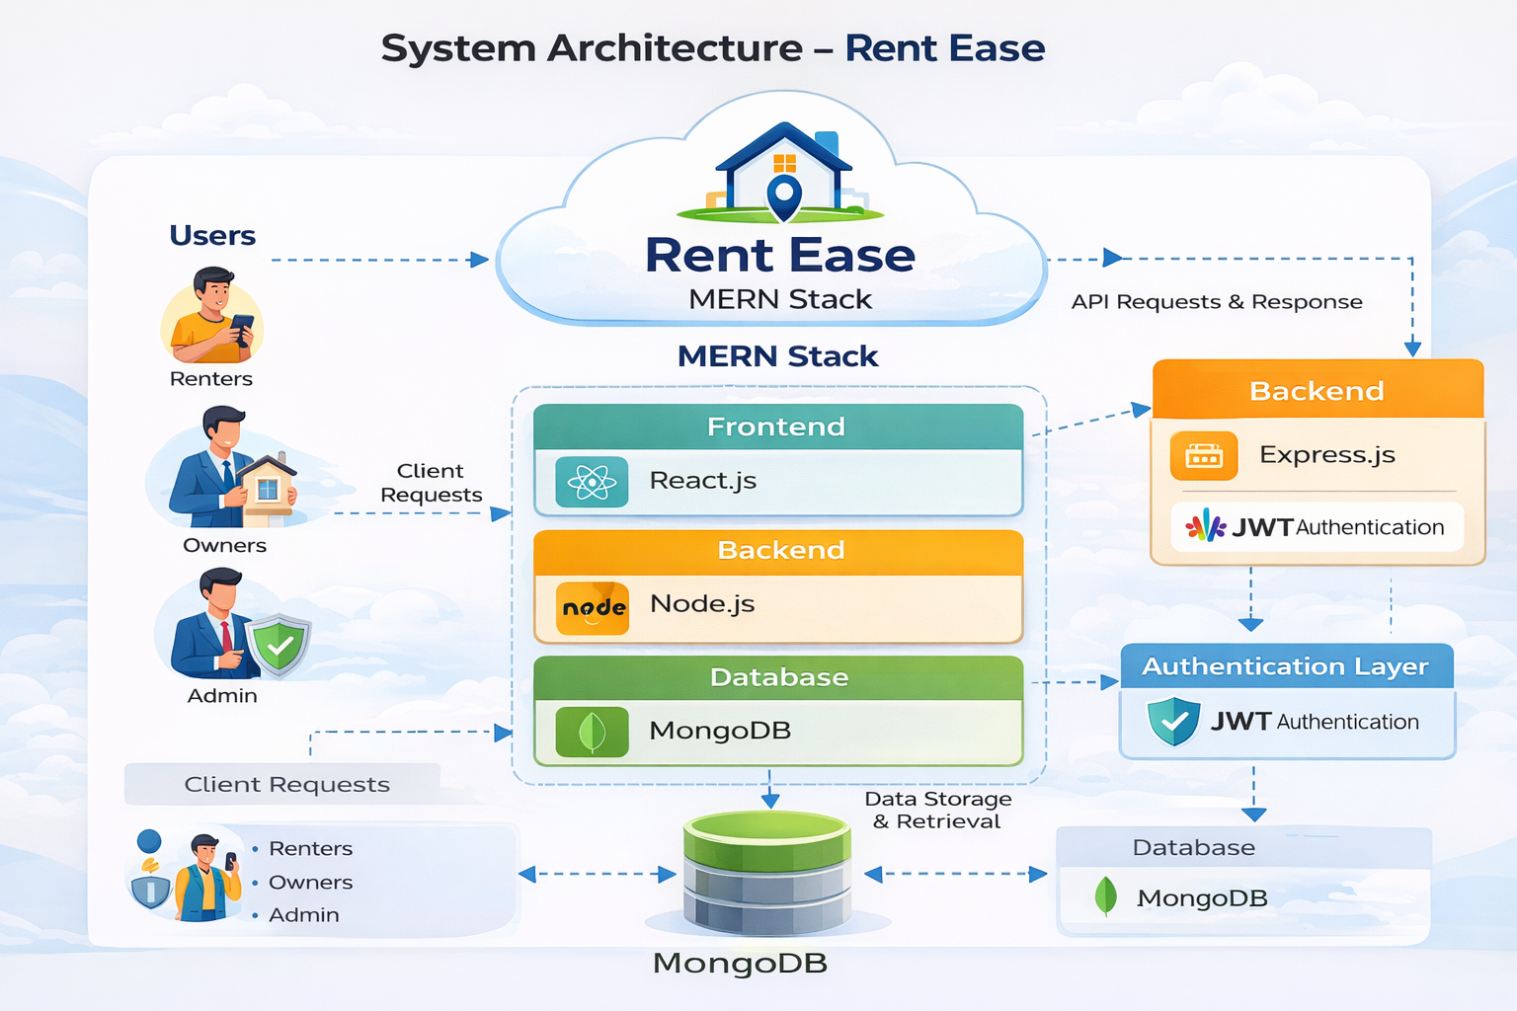
- Authentication: JSON Web Tokens (JWT)

4. Component Explanation
• User Interface:
Developed using React.js, it provides interactive pages for renters, owners, and administrators.
• Client Requests:
User actions such as registration, login, property listing, and booking are sent as HTTP requests to the backend.
• Backend Server:
Express.js handles API requests, validates data, applies business logic, and manages authentication.
• Authentication Layer:
JWT ensures secure access and role-based authorization.
• Database Layer:
MongoDB stores user profiles, property details, and booking records.
• Response Handling:
The backend sends responses back to the frontend for display and further interaction.

5. Conclusion
The proposed solution architecture ensures a secure, scalable, and efficient house rental management system. By integrating modern web technologies, Rent Ease eliminates manual processes, improves transparency, and provides a seamless rental experience for renters, property owners, and administrators.

